

**Group Members: (Group 1-ODD)**

|  |  |  |  |
| --- | --- | --- | --- |
| 220603 | 220605 | 220607 | 220609 |
| 220611 | 220613 | 220615 | 220617 |
| 220621 | 210601 | 210631 |  |

**Index:**

|  |  |
| --- | --- |
| 01 | What are the different criteria for system stability? |
| 02 | What are the basic properties of a system? Explain causality and stability. |
| 03 | Define and explain the significance of the impulse response of an LTI system. |
| 04 | State and proof Parseval’s theorem. |
| 05 | Some Mathes of Fourier Transform. |

**Assignment**

**Q1. What are the different criteria for system stability?**

**Stability:** The stability of the system means when a controlled input is provided to any dynamic system, it must result in providing the controlled output. In other words, the system must be BIBO stable i.e., bounded input bounded output system. If the system is not in our control i.e., uncontrolled output is obtained on providing the bounded input then the system is said to be unstable.

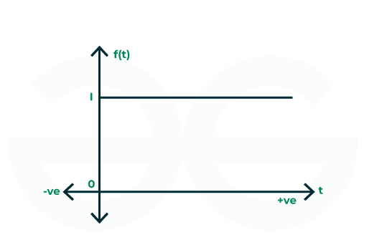

Figure 01: Unit Step Signal (Bounded Signal)

The above image shows a Unit Step Signal which is an example of the bounded signal. When the value of time (t) on the x-axis increases, the output value remains 1. This shows that the above signal is stable.

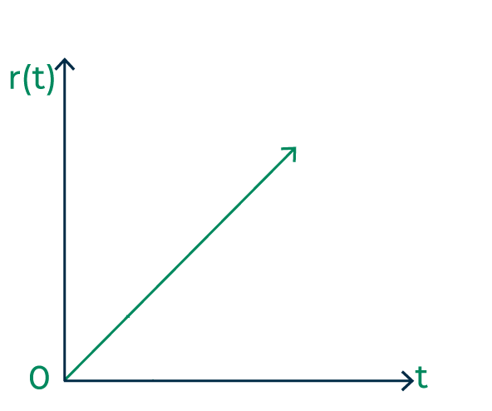

Figure 02: Continuous time Unit Ramp Signal

The above image shows a Unit Ramp Signal which is an example of the un-bounded signal. When the value of time (t) on the x-axis increases, the output value increases continuously. This shows that the above signal is unstable.

**Types of Stability**

There are 3 types of stability which are as follows:

* Steady State Stability
* Transient Stability
* BIBO Stability

**Steady State Stability**

Steady-state stability means when a system is subjected to constant input for a long duration of time and the system results in a stable output, it is known as steady-state stability. When a dynamic system provides a stable output during any disturbance in the input, it is said to be a stable system.

**Transient Stability**

When a system changes its state, it is known as a transition. During the transition period, whether the system is stable or not when subjected to some disturbance is determined by the transient stability.

**BIBO Stability**

Bounded input and bounded output stability show a system is stable when the system returns the bounded output when the bounded input is given. When the output is controllable, the system is stable else it is unstable.

**Types of System Based on Stability**

There are 3 types of system based on stability:

* Completely Stable System
* Marginally Stabel System
* Conditionally Stable System
* Unstable System

**Completely Stable System**

As the name suggests, a completely stable system provides a stable output for all ranges of values. One way to identify a completely stable system is to check the poles of the transfer function. If the poles of the open and closed loop system lie in the left half of the s-plane, then the system is completely stable.

The graph given below shows the completely stable system

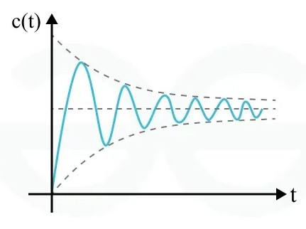

Figure 03: Completely stable system

**Marginally Stable System**

A marginally stable system is a system that is stable for the current or present value. Any disturbance in the input can make the output of the system unstable. The marginally stable system can be identified when the poles of the open closed and closed loop system lie on the imaginary axis of the s-plane. The graph given below is the example of marginally stable system.

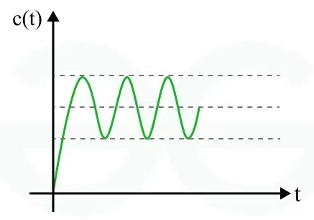

Figure 04: Marginally stable system

**Conditionally Stable System**

When a system is stable for certain values, then it is known as a conditionally stable system. The system can become unstable during the transient response. In simple terms, a conditionally stable system is stable only when the loop gain of a system is in a particular range. The image given below shows a conditionally stable system.

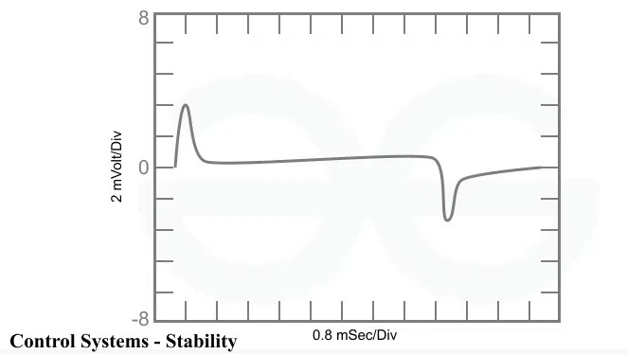

Figure 05: Conditionally stable system

**Unstable System**

A system is said to be unstable when it produces uncontrolled output. The unstable system can be identified when the open and closed loop poles are on the right half of the s-plane. The given graph shows the unstable system.

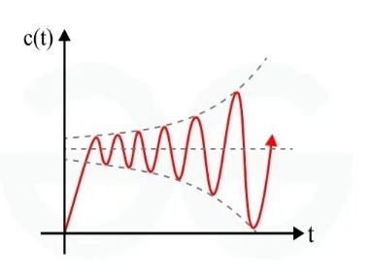

Figure 06: Unstable system

**Q2. What are the basic properties of a system? Explain causality and stability.**

**System**

A System is any physical set of components or a function of several devices that takes a signal in input, and produces a signal as output. These components interact with each other and with the environment to perform the function or process that will contribute to the system

y(t)

x(t))

System

Output signal

input signal

Properties of system

Base on the properties, the system can be classified as

* Continuous time and Discrete time system
* Stable and Unstable system
* Memory and Memoryless system
* Invertible system and Noninvertible system
* Time Variant and Time Invariant system
* Linear and Nonlinear system
* Causal and Noncausal system

**Causality property of system**

A system is **causal** if its output at any time ttt depends only on present and past inputs, but not on future inputs. This means that the system does not anticipate future inputs before they occur.

**Mathematical Representation**

A system is causal if:

y(t)=f(x(t), x(t−1), x(t−2), ...)

but does not depend on x(t+1), x(t+2) etc.

**Example of a Causal System**

y(t)=x(t)+2x(t−1)

Here, the output depends on the present and past input values, making it causal.

**Example of a Non-Causal System**

y(t)=x(t+1) + x(t)

Here, the output depends on a future input x(t+1), making it non-causal.

**Stability**

A system is **stable** if for every bounded input, the output remains bounded. This means that if the input signal does not grow indefinitely, the output should also remain finite.

**Mathematical Condition**

A system is stable if it satisfies the Bounded Input - Bounded Output (BIBO) stability condition:

If ∣x(t)∣≤Mx​ for all t, then ∣y(t)∣≤My​ for some finite My​.

Example of a Stable System y(t)=x(t)/2

Since the output is always proportional to the input and does not grow unbounded, the system is stable.

​ Example of an Unstable Syste y(t)=t*x(t)

If x(t) is bounded, y(t) can still grow indefinitely as t increases, making the system unstable

**Q3. Define and explain the significance of the impulse response of an LTI system.**

**Impulse Response of an LTI System**

The impulse response of a Linear Time-Invariant (LTI) system is the output of the system when the input is a unit impulse function, denoted as δ(t**)** in continuous time and δ[n] in discrete time. It is a fundamental characteristic of an LTI system and is usually denoted by h(t)for continuous-time systems and **h[n]** for discrete-time systems.

**Mathematical Definition**

For a continuous-time LTI system, if the input is x(t) and the output is y(t), the system's response to an impulse input δ(t) is called the impulse response h(t):

h(t)=Response of the system to δ(t)

For a discrete-time LTI system:

h[n]=Response of the system to δ[n]

**Significance of Impulse Response**

The impulse response is significant for the following reasons:

* The impulse response contains all the information needed to describe an LTI system. If we know h(t), we can determine the system’s output for any arbitrary input.
* In continuous-time systems, the output y(t) for any input x(t) can be found using the convolution integral: y(t)=h(t−τ) dτ
* In discrete-time systems, the output y[n] is obtained using the convolution sum: y[n]=k=
* The Fourier transform of the impulse response gives the system’s frequency response H(f), which tells us how the system modifies different frequency components of the input. H(f)=
* A system is BIBO (Bounded Input-Bounded Output) stable if and only if its impulse response is absolutely integrable <

In discrete-time systems:

<

**Q4. Stay and proof Parseval’s theorem.**

**Statement** – Parseval’s theorem states that the energy of signal x(t) [if x(t) is aperiodic] or power of signal x(t) [if x(t) is periodic] in the time domain is equal to the energy or power in the frequency domain.

Therefore, if,

x1(t) ↔ X1(ω) and x2(t) ↔ X2(ω)

Then, Parseval’s theorem of Fourier transform states that

dt=X1 dω

Proof

Parseval’s relation is given by,

dt=X1 dω

From the definition of inverse Fourier transform, we have,

LHS = dt =

changing the order of integration in RHS of the above expression, we get,

dt = dw

dt = d

dt = = RHS

**Q5. Math of Fourier Transform**

**Determine the Fourier transform of the signal x(t) =**

Solution By definition of FFT

X(j) = dt

= dt

= dt + dt

= dt + dt

= dt + dt

= +

X(j) = + =



